Brings you one more opportunity for reliving the
IRAN

TRAVEL WITH THE EXPERT IN ORDER TO EXPERIENCE THE RELIGION:

KHOJESTE MISTREE WILL BE YOUR GUIDE AND FRIEND THROUGHOUT THE TOUR!!

14days-Best Value For Money.
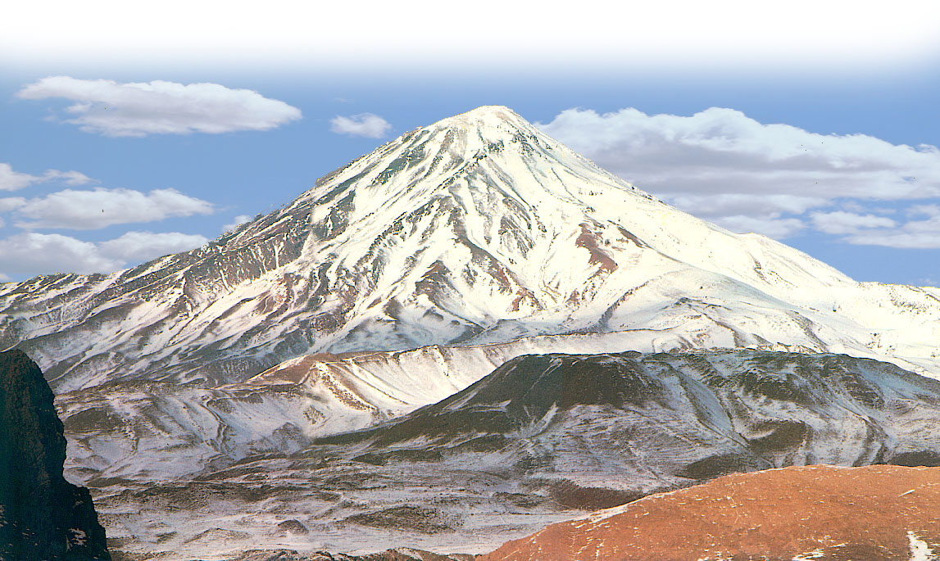

SPECIAL OFFER
Dep: 13th, Apr. 2007

Arr : 27th, Apr, 2007

Visiting:

TEHRAN  KERMANSHAH  TAQ –e BUSTAN 

ISFAHAN  THE OLDEST BRIDGE IN THE WORLD
 KUH-e ALVAND  ALI SADR CAVES  
SHIRAZ  PERSEPOLIS/TAKHT –e JAMSHEED  
 NAQSH –e RUSTOM  PASARGADAE  
YAZD & ITS ENVIRONS (INCLUDING THE SIX PIRS AND SOME IMPORTANT FIRE TEMPLES)
JASHANS AT MT.DEMAVAND & PIR-e SABZ (overnight stay) 
VISIT MORE MUSEUMS, PALACES, SHRINES & HISTORICAL SITES THAN
ANY OTHER INDIA BASED TOUR GROUP!!

Unique educational action packed tour that will rekindle your religious passion and give you an exciting holiday

Contact : DEMAVAND TOURS, Mumbai.
KATY will be glad to give you more information.
Tel: (+91-22) 2283-1511/2204-7990; FAX:(+91-22) 2281-8038;
Email : zstudies@vsnl.com, zstudies@gmail.com
Weekdays between 11.30 am & 5.30 pm.

